Nonesi Fuels Progress Report 06

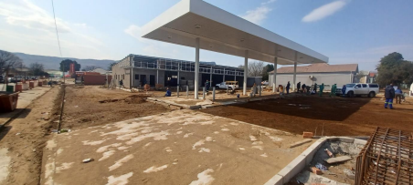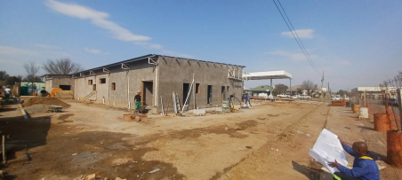Site Report: 02 August 2022

Contents

1. Progress of the work .......................................................................................................................4 1.1. Main Contractor: Adrocon.......................................................................................................4 1.1. Sub-Contractors ......................................................................................................................4

1.1.1. Civil and General..............................................................................................................4 1.1.2. Fuel Tech Tanks...............................................................................................................4 1.1.3. Fuel Tech Canopy ............................................................................................................4 1.1.4. MD Engineering...............................................................................................................5 1.1.5. RV Smith ..........................................................................................................................5

2. Planned works (for the upcoming month).......................................................................................5 2.1.1. Casting of the slab over the Fuel tanks................................................................................5 2.1.2. Aluminium shopfronts and windows...................................................................................5 2.1.3. Installation of ceilings and portions.....................................................................................5 2.1.4. Painting internally of the super structure............................................................................5 2.1.5. Tiling ....................................................................................................................................5 2.1.6. Installation of the water supply line and fire hydrant to site...............................................5 2.1.7. Installation of the sewer line into Bells Road.......................................................................5 2.1.8. External Grey interlocking paving........................................................................................5 2.1.9. Iron spot paving...................................................................................................................5 2.1.10. Installation of the Beta fence ..............................................................................................5

3. Health and Safety ............................................................................................................................5 4. Environmental .................................................................................................................................6 5. Quality .............................................................................................................................................6 6. Commercial .....................................................................................................................................6 7. Contractual......................................................................................................................................7

7.1.1. Site instructions and Variation orders.................................................................................7 7.1.2. Delays..................................................................................................................................8 8. Program...........................................................................................................................................8 8.1. Program analysis since previous Report......................................................................................8 8.2. Anticipated Delays.......................................................................................................................8 8.2.1. Fresh Stop............................................................................................................................8 8.2.2. Chris Hani Water Line..........................................................................................................8 8.2.3. Tiles in Shop.........................................................................................................................8 8.2.4. Pollution solution tank.........................................................................................................8

2 | P a g e

List of Tables

Table 1: Summary of Payment................................................................................................................6 Table 2: Summary of Instruction issued by Professional Team..............................................................7 Table 3 Summary of Delays.....................................................................................................................8 Table 4 Program Items from Previous Month ........................................................................................8

List of Figures

Figure 1 Steel Internal Surface beds after casting ..................................................................................9 Figure 2 Shop surface beds 02 August 2022...........................................................................................9 Figure 3 Casting of the Forecourt drainage channel.............................................................................10 Figure 4 Photo of Site from Northern corner 2nd August 2022.............................................................10 Figure 5 Photo of internal Walls ...........................................................................................................11 Figure 6 ATM Slab reinforcement.........................................................................................................11 Figure 7 Photo of Site from Eastern corner 2nd August 2022 ...............................................................11 Figure 8 Thrust block for water supply .................................................................................................12 Figure 9 Storm water channel in Bells Road.........................................................................................12 Figure 10 Forecourt Cast 1....................................................................................................................13

3 | P a g e

1. Progress of the work

1.1. Main Contractor: Adrocon

Adrocon have successfully completed the casting of the surface beds in the superstructure. And are continuing with the internal brickwork where possible.

The roof covering is 98% complete. Flashing details has been approved and the sub-contractor has been notified to complete the work.

Externally the kerb lines have been established and placed. The cutting of the final level is underway. And the paving orders are confirmed to be arriving this week ending the 5th of August 2022.Casting of the forecourt slab has been completed. And the surrounding channel casting Is underway. There is an issue regarding the levels of the pollution solution tank and the levels required to cover the tank and the fall available for all the piping to connect to the sewerage system. Fuel Tech have been requested to give more information to the Engineer on this.

The main water supply line for the fire hydrant and water supply line has been laid, tested, and backfilled. The sewerage lines are being laid and the sewerage connection in the road has been established.

Chris Hani District Municipality are delaying the project with the main water supply to site. Adrocon are unable to lay the reuired 160mm water line and perform the water mains and hydrant connection until the water main connection point has been installed. Chris Hani Have missed numerous dates supplied to us for the connection.

There are a few minor details to be cleared up regarding kerb heights to complete the kerbing for the external surface beds and paving to commence.

1.1. Sub-Contractors

1.1.1.Civil and General

Civil and General have completed the main platform and the side on and off ramps. Civil and General have been issued with an interim works completion certificate for the main platform, this dated 25th March 2022.

Civil and General must remove some of the spoil for the excavations for the Bells Road and Komani Street on and off ramps. Civil and General have removed 95% of their spoil.

1.1.2.Fuel Tech Tanks

Fuel tech have completed the installation of the tanks and sleaves. Fuel tech require the sewerage height to be finalized and instructed, by the engineer, that the depth of the pollution Solution can be installed. There is an issue regarding the required heights for this pollution solution tank.

1.1.3.Fuel Tech Canopy

Fuel Tech have erected the canopy structure. And completed the installation of the bollards around the pumps. Fuel tech require instruction on the position of the pylon base.

4 | P a g e

1.1.4. MD Engineering

MD Engineering have erected the structure of the shop and completed all steel work pertaining to the shop super structure.

The eating area structure is complete and is awaiting installation.

1.1.5.RV Smith

RV Smith appointed by Adrocon cc for the roof covering.

RV Smith are on site to install the suspended ceiling and partitions.

2. Planned works (for the upcoming month)

2.1.1.Casting of the slab over the Fuel tanks

2.1.2.Aluminium shopfronts and windows.

2.1.3.Installation of ceilings and portions

2.1.4.Painting internally of the super structure

2.1.5.Tiling

2.1.6.Installation of the water supply line and fire hydrant to site

Chris Hani District Municipality have been to site on numerous occasions. This was to consult with the Engineer and Adrocon. There have been numerous different discussions on how to get the required water supply to site as the original information supplied to the design team and contractor is incorrect.

It was discussed that Chris Hani will undertake to do the connection to the existing water main on the corner of Sprigg Street and Komani Street as numerous surrounding businesses and homes will be affected while the installation is undertaken. Chris Hani have requested that the Client supply the fittings required for the connection, as Chris Hani are not able to procure the fittings. Chris Hani exposed the water main that will be tied into. It was established that the pipe is a 160mm steel pipe.

Chris Hani have supplied the list of fittings required for the connection at the corner of Sprigg Street and Komani Street. Quote for fittings supplied to Professional team.

2.1.7.Installation of the sewer line into Bells Road

2.1.8.External Grey interlocking paving

2.1.9. Iron spot paving

2.1.10. Installation of the Beta fence

3. Health and Safety

There have been no health and Safety issues on Site.

The labour department have been to site to inspect and approve the Health and Safety File of Adrocon cc.

All Sub-contractors have been asked to always supply and have a Health and Safety File on Site.

5 | P a g e

4. Environmental

No Rain events this month.

5. Quality

There have been no quality issues to Date.

6. Commercial

Summary of Payment

| Date: | Amount (Incl VAT): | Status |
| --- | --- | --- |
| February 2022 | R 1 787 341.11 | Paid |
| April 2022 | R 1 275 672.23 | Paid R 1 000 000 on  20/05/2022  Paid R 275 672.23 on  14/06/2022 |
| May 2022 | R 1 001 760.57 | Paid R 1 001 760.57 on  14/06/2022 |
| June 2022 | R 1 280 413.06 | Paid R886 743.69 on  05/07/2022  Paid R 393 670.00 on  20/07/2022 |
| July 2022 | R 1328 494.48 | Paid R 1328 494.48  02 / 08 /2022 |

Table 1: Summary of Payment

6 | P a g e

7. Contractual

7.1.1.Site instructions and Variation orders

| Date: | Instruction Number: | Summary of Instruction |
| --- | --- | --- |
| 16 February 2022 | 1 | Demolish Fence on 3rd Side, Remove trees. Provide  temporary Fencing to 3rd Side |
| 16 February 2022 | 2 | Hand Excavation to expose services |
| 01 March 2022 | 3 | 1. Hand excavations around services  2. Concrete to be cast over services to protect them  3. Move entrance/exit  kerbing in Komani road  South-eastern corner by  500mm  4. Provide Hoarding to Site |
| 08 April 2022 | 4 | Concrete pour on Eastern and Southern Side approval |
| 12 April 2022 | 5 | FFL lifted to 1069.790 |
| 18 July 2022 | 6 | Locate water main from site boundary |
| 18 July 2022 | 7 | Located 160mm class 16 pipe, Purchase 100m class  16 160mm pipe  Purchas fittings as per list |
| 18 July 2022 | 8 | Locate sewer pipe in midblock road. Information from CHDM incorrect |
| 19 July 2022 | 9 | Could not locate sewer pipe in mid-block road.  Follow sewer pipe into bells road |
| 19 July 2022 | 10 | Concrete between existing paving and drain section  damaged.  Extend dish drain |
| 19 July 2022 | 11 | Sewer junction in Bells Road to be turned into a Manhole |

**TABLE 2: SUMMARY OF INSTRUCTION ISSUED BY PROFESSIONAL TEAM**

7 | P a g e

7.1.2. Delays

| EOT number | Description: | Date Submitted: | Days  Requested: | Status: |
| --- | --- | --- | --- | --- |
| 1 | Rain Delays | Notification  submitted | 4 | Approved |
| 2 | Rain Delays | Notification  submitted | 3 | Approved |

**TABLE 3 SUMMARY OF DELAYS**

8. Program

8.1. Program analysis since previous Report

| Program item | Progress | Start | End | Comment |
| --- | --- | --- | --- | --- |
| Roofing Installation (RV Smith) | 98% | 01 June 2022 | 29 June 2022 | Flashing to be installed as per agreed detail |
| Electrical First Fix (Wayne’s Electrical) | 100% | 31 May 2022 | 11 July 2022 |  |
| Plumbing First Fix | 70% | 31 May 2022 | 02 August  2022 |  |
| Cast Concrete Surface Beds | 100% | 31 May 2022 | 16 August  2022 |  |
| Internal and External  Plaster (±1300m2) | 85% | 16 June 2022 | 28 July 2022 |  |
| Laying of Water supply Lines (Fire Hydrant and general water) | 75% | 06 May 2022 | 01 August  2022 |  |
| Laying of sewerage lines to building | 50% | 28 June  2022 | 29 July  2022 |  |
| Stormwater Installation | 30% | 25 June  2022 | 11 August  2022 |  |
| Laying of Kerbs | 60% | 24 June  2022 | 24 August  2022 |  |
| Electrical First Fix (Wayne’s Electrical) | 20% | 31 May 2022 | 11 July 2022 |  |

**TABLE 4 PROGRAM ITEMS FROM PREVIOUS M~~ONTH~~**

8.2. Anticipated Delays

8.2.1.Fresh Stop

The contractor is currently waiting communication to clarify the scope of works to be

undertaken by Fresh stop shop outfitters.

8.2.2.Chris Hani Water Line

Waiting for Chris Hani to install the water connection point in Komani Road.

8.2.3.Tiles in Shop

CTM have discontinued the main floor tile Shante dark wood

8.2.4. Pollution solution tank

8 | P a g e

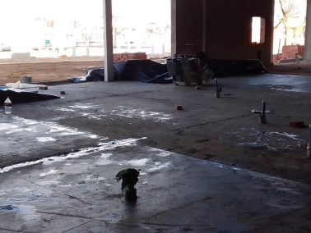**FIGURE 1 STEEL INTERNAL SURFACE BEDS AFTER CASTING**

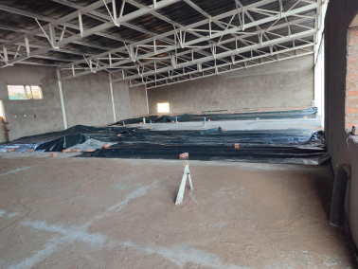**FIGURE 2 SHOP SURFACE BEDS 02 AUGUST 2022**

9 | P a g e

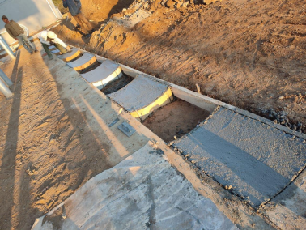**FIGURE 3 CASTING OF THE FORECOURT DRAINAGE CHANNEL**

**FIGURE 4 PHOTO OF SITE FROM NORTHERN CORNER 2ND AUGUST 2022**

10 | P a g e

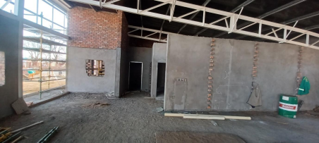**FIGURE 5 PHOTO OF INTERNAL WALLS**

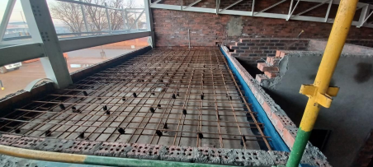**FIGURE 6 ATM SLAB REINFORCEMENT**

**FIGURE 7 PHOTO OF SITE FROM EASTERN CORNER 2ND AUGUST 2022**

11 | P a g e

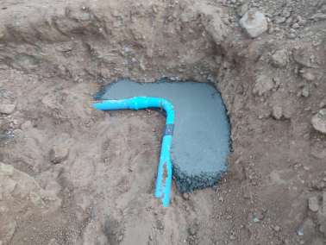**FIGURE 8 THRUST BLOCK FOR WATER SUPPLY**

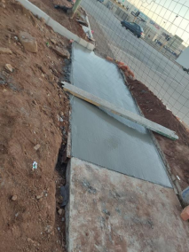

**FIGURE 9 STORM WATER CHANNEL IN BELLS ROAD**

12 | P a g e

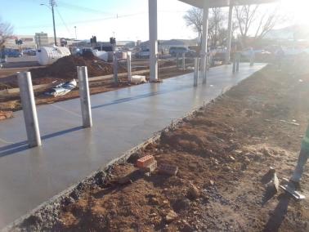**FIGURE 10 FORECOURT CAST 1**

13 | P a g e